Analyzing HTTP GET AND POST requests
POST request

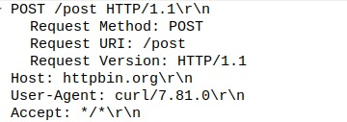
POST response
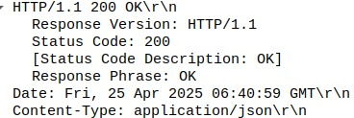
GET request
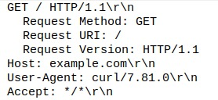
GET RESPONSE
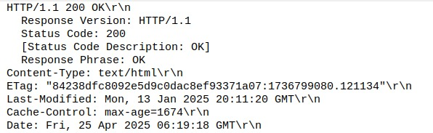
B) MIME type of the response.
Text/html
c) HTTP status code and explanation
200 OK means that the request was successful and the server is sending the requested data.

